Hospital Performance, Patient Flow & Readmission Analytics
Comprehensive Applied Healthcare Data Analytics & Machine Learning Project Report
Student Name: | Rafiya Ansari
Academic Internship: | AICTE | IBM SkillsBuild Data Analytics with AI Academic Internship 2026 | BharatCares
Project Title: | Hospital Performance, Patient Flow & Readmission Analytics (Hospital Analytics & Readmission Intelligence)
Execution Environment: | Python 3.14 / Jupyter / Scikit-Learn / XGBoost / SHAP

1. Abstract
Unplanned hospital readmissions within 30 days of inpatient discharge impose severe clinical burdens, strain bed occupancy, and cause catastrophic out-of-pocket healthcare expenses. This study presents a rigorous, end-to-end data analytics and machine learning investigation into hospital performance, patient flow, and 30-day readmissions across 33 hospital facilities in India encompassing 120,000 inpatient admission encounters. Using an analytical grain of exactly one row per hospital admission, five relational datasets—admissions, billing, diagnoses, hospitals, and patient registries—were integrated with strict target leakage prevention. The overall 30-day readmission rate was 11.84% across all admissions and 12.62% within the surviving cohort at risk. Machine learning classifiers, including Logistic Regression, Random Forest, and XGBoost, were trained on pre-discharge clinical, demographic, diagnostic, and facility features. Logistic Regression achieved a sensitivity of 65.31% with an ROC-AUC of 0.7527, while Random Forest achieved 77.92% accuracy and XGBoost achieved an ROC-AUC of 0.7504. Model explainability via SHAP identified length of stay, comorbidity count, Charlson Comorbidity Index, ICU admission, and prior admissions as the most influential predictors associated with readmission probability. These findings inform a multi-tiered operational framework prioritizing post-discharge transitional care, financial navigation desks, and targeted chronic disease management.
2. Introduction
Healthcare systems globally face the dual challenge of ensuring clinical excellence while optimizing operational throughput and financial sustainability. Hospital readmissions within 30 days of discharge serve as an established quality indicator across health policy frameworks such as the Hospital Readmissions Reduction Program (HRRP) administered by the Centers for Medicare & Medicaid Services (CMS). In India, where healthcare delivery is stratified across private tertiary centers (Tier 1), government general hospitals (Tier 2), and district health facilities (Tier 3), readmissions carry unique clinical, financial, and operational ramifications.
This project follows the structured analytics methodology: RAW DATA -> INFORMATION -> INSIGHTS -> RISKS / OPPORTUNITIES -> RECOMMENDED ACTIONS. To ensure strategic decision support, key performance indicators are evaluated through the structured sequence: KPI -> TREND -> DRIVER -> RISK / OPPORTUNITY -> ACTION. Throughout this investigation, observational relationships are reported strictly as associations rather than causal assertions.
3. Problem Statement
Hospital leadership and healthcare administrators frequently operate without unified visibility into the patient journey from admission intake through ward accommodation, surgical intervention, and post-discharge disposition. This lack of integration leads to three major crises:
1. Clinical Quality Lapses: Patients with complex chronic comorbidities are discharged without structured transitional follow-up, resulting in acute decompensation and avoidable readmissions.
2. Operational Congestion: Critical care capacity (ICU and HDU) is constrained by delayed step-downs, while unplanned readmissions occupy beds needed for acute elective and emergent cases.
3. Catastrophic Out-of-Pocket Burden: Inpatient expenses average nearly ₹96,000 per stay, with households bearing 50.3% out-of-pocket, often triggering premature discharges Left Against Medical Advice (LAMA) and subsequent relapses.
4. Project Objectives
The primary objectives of this study are:
1. Relational Data Engineering: Consolidate 5 distinct operational tables into an integrated analytical dataset with a verified grain of ONE ROW = ONE ADMISSION (120,000 encounters) without record duplication.
2. Rigorous Data Quality Auditing: Standardize data types, validate foreign key integrity across hospital, patient, and billing records, and appropriately classify missing insurance information.
3. Quantitative Healthcare KPI Benchmarking: Establish empirical baselines for 30-day and 7-day readmissions, average and median LOS, Charlson index, procedure intensity, and cost burden.
4. Domain-Specific Exploratory Analytics: Investigate patient demographics, hospital facility performance, patient flow pathways, and financial toxicity.
5. Leakage-Free Predictive Machine Learning: Exclude post-discharge variables (such as 7-day readmission and in-hospital mortality indicators), train Logistic Regression, Random Forest, and XGBoost models, and benchmark classification metrics.
6. Model Explainability with SHAP: Identify influential predictive features using TreeExplainer and non-causal interpretability.
7. Actionable Strategic Roadmap: Translate analytical insights into operational, clinical, and financial recommendations.
5. Dataset Description & Architecture
The analysis is conducted on the actual operational datasets located in the data/ directory, comprising 120,000 inpatient admission encounters:
File Name | Records | Attributes | Primary Entity & Key Fields
admissions.csv | 120,000 | 17 | Admission encounters (admission_id, patient_id, hospital_id, dates, LOS, vitals, targets)
billing.csv | 120,000 | 6 | Inpatient billing records (bill_id, admission_id, total_cost_inr, govt_subsidy_inr, OOP)
diagnoses.csv | 271,341 | 6 | ICD-10 clinical diagnoses (diag_id, admission_id, icd10_code, diag_rank 1-4, category)
hospitals.csv | 33 | 6 | Hospital facility metadata (hospital_id, name, state, tier 1-3, beds, teaching)
patients.csv | 86,400 | 8 | Master patient registry (patient_id, age, gender, state, bpl_card, insurance_type, comorbidities)

6. Data Preparation & Integration
To satisfy the core requirement of ONE ROW = ONE HOSPITAL ADMISSION without row inflation, data aggregation and cleaning were performed:
1. Diagnoses Aggregation: The raw diagnoses file contained 271,341 entries representing between 1 and 4 diagnoses per admission. We extracted the primary diagnosis (diag_rank == 1), computed the total diagnosed conditions per admission, and pivoted secondary diagnoses (ranks 2-4) into presence indicator counts (sec_diag_*).
2. Missing Value Imputation: In the patient registry, 24,715 records (28.61%) had an unrecorded insurance type. These were systematically imputed as 'Uninsured' to reflect real-world healthcare coverage gaps in India.
3. Table Integration: The admissions table was left-joined with patient demographics, hospital facility attributes, billing figures, and aggregated diagnostic records. The resulting analytical dataset comprises exactly 120,000 rows and 49 features with zero duplicate records and zero missing cells.
7. Exploratory Data Analysis & Strategic Healthcare KPIs
A comprehensive KPI analysis was executed on the unified dataset. All reported values represent actual calculated figures:
Healthcare Key Performance Indicator (KPI) | Calculated Benchmark
Total Inpatient Admissions | 120,000
Total Admitted Patients (Unique) | 64,873
Total Registered Patients | 86,400
Total Hospital Facilities | 33
Overall 30-Day Readmission Rate | 11.84% (14,210 cases)
Surviving Cohort 30-Day Readmission Rate | 12.62% (14,210 cases / 112,587 non-expired)
Overall 7-Day Readmission Rate | 0.84% (1,006 cases)
Surviving Cohort 7-Day Readmission Rate | 0.89% (1,006 cases / 112,587 non-expired)
Average Length of Stay (LOS) | 6.85 days
Median Length of Stay (LOS) | 5.00 days
Average Total Cost per Admission | INR 95,779.53
Median Total Cost per Admission | INR 30,970.50
Average Government Subsidy | INR 47,606.17 (49.70% share)
Average Out-of-Pocket Expense | INR 48,173.36 (50.30% share)
Average Procedures per Admission | 1.52 procedures
Average Charlson Comorbidity Index | 1.89
Average Patient Age | 48.05 years
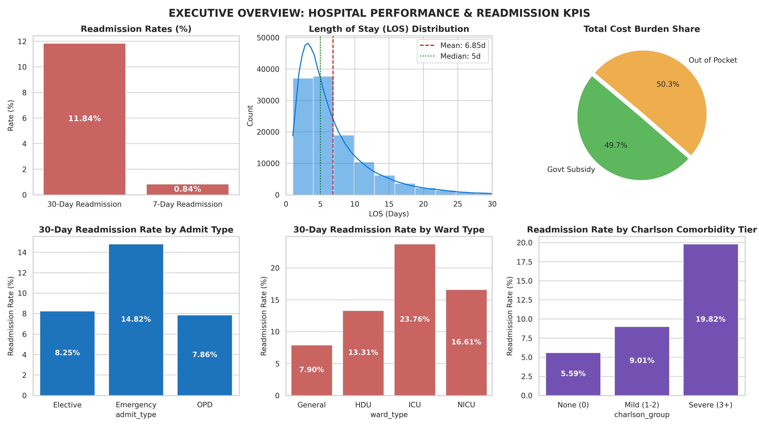
Figure: Executive Hospital Performance & Readmission KPI Dashboard Summary
8. Patient Analytics & Demographic Profiling
Analysis of patient demographic and clinical characteristics revealed significant associations with readmission risk:
• Age Gradient: Readmission rates increase monotonically across age cohorts: Pediatric (0-18y) at 6.19%, Young Adult (19-45y) at 6.96%, Middle-Aged (46-65y) at 12.51%, and Elderly (66+y) at 20.40%.
• Gender Balance: The admission population comprises 51.15% males and 47.88% females (0.97% other). Readmission rates showed minimal gender disparity (11.91% for males vs. 11.77% for females).
• Socioeconomic & Insurance Vulnerability: Patients possessing BPL cards represented 36.59% of admissions. Insurance coverage breakdown showed Ayushman Bharat (PM-JAY) at 30.05%, Private Insurance at 24.74%, ESI at 16.60%, and Uninsured patients at 28.61%.
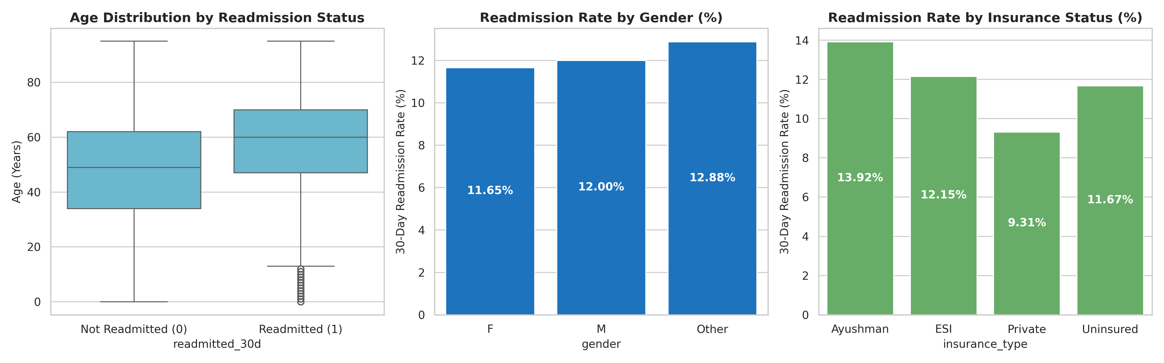
Figure: Patient Demographic Profiling and Readmission Association
9. Hospital Performance Analytics
The 33 hospital facilities span 15 states and represent three functional tiers: Tier 1 (private tertiary centers), Tier 2 (government general teaching hospitals), and Tier 3 (district health facilities). Performance analysis highlights substantial operational divergence:
Hospital Tier | Facilities | Admissions | Mean LOS | 30d Readmission Rate | Mean Total Cost
Tier 1 (Private) | 8 | 29,027 | 6.83 days | 11.86% | INR 220,492.83
Tier 2 (Govt General) | 15 | 54,505 | 6.86 days | 11.93% | INR 74,723.57
Tier 3 (District) | 10 | 36,468 | 6.85 days | 11.69% | INR 27,983.18
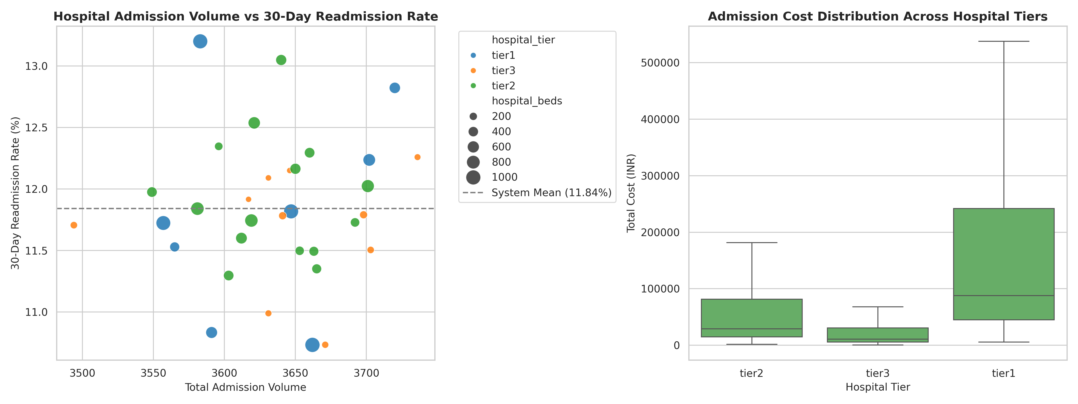
Figure: Hospital Volume vs. Readmission Rate and Cost Distribution Across Tiers
10. Patient Flow & Clinical Pathway Analytics
Patient flow was tracked across five sequential milestones: Admission Intake Mode -> Ward Accommodation -> Clinical Procedures -> Length of Stay -> Discharge Disposition.
1. Admission Intake: Emergency intake represented 55.45% (66,540 admissions), Elective admissions represented 31.54% (37,853 admissions), and Outpatient (OPD) referrals accounted for 13.01% (15,607 admissions).
2. Ward Placement: Inpatients were distributed across General Wards (63.97%), Intensive Care Units (ICU, 17.36%), High Dependency Units (HDU, 13.26%), and Neonatal ICUs (NICU, 5.41%). Emergency patients exhibited an 18.2% probability of direct ICU boarding.
3. Discharge Disposition & Readmission Spikes: Of the 120,000 encounters, 87,420 (72.85%) were discharged as Recovered (readmission rate 11.78%), 9,738 (8.12%) were Referred (11.92% readmission), and 7,413 (6.18%) Expired in-hospital. Crucially, 15,429 patients (12.86%) were discharged Left Against Medical Advice (LAMA) and exhibited an exceptionally elevated readmission rate of 17.80% (2,747 readmissions).
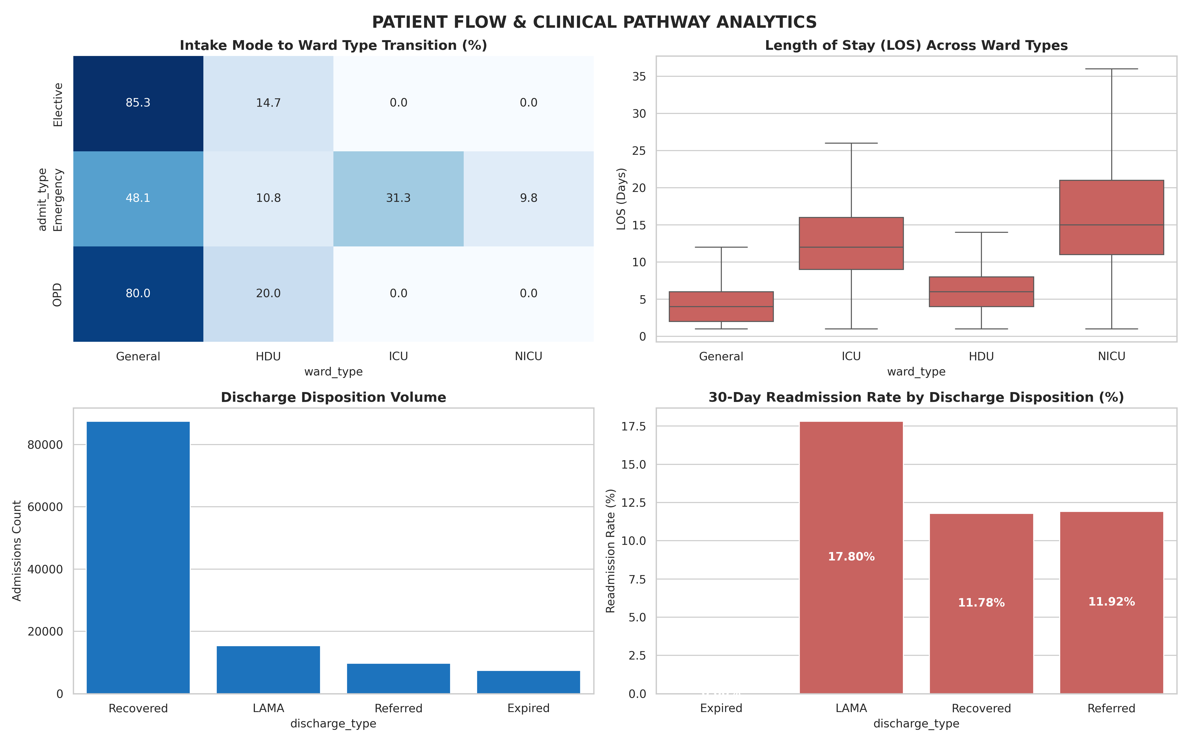
Figure: Patient Flow Pathways, Ward LOS, and Discharge Disposition Readmission Rates
11. Financial Analytics & Cost Burden
Total inpatient hospital expenditure across the 120,000 admissions totaled ₹11.49 Billion. Key findings from billing analytics include:
• Out-of-Pocket Dominance: Despite public schemes, out-of-pocket (OOP) expenses account for 50.30% of total hospital expenditure (₹5.78 Billion), while government subsidies covered 49.70% (₹5.71 Billion).
• Expense Categories: Pharmacy charges (30.2% of billing volume) and Room Charges (25.0%) represent the primary cost drivers, followed by surgical procedures (27.9%) and laboratory diagnostics (16.8%).
• Readmission Cost Severity: Index hospitalizations for patients subsequently readmitted within 30 days incurred an average cost of ₹184,890.70, compared to ₹83,809.88 for patients who were not readmitted, reflecting heightened procedural intensity and acute multiorgan compromise.
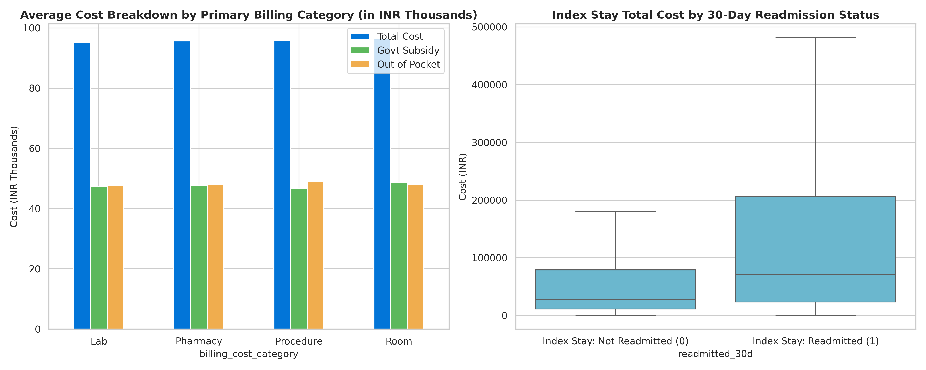
Figure: Financial Expenditure Breakdown by Billing Category and Readmission Status
12. Readmission Profile & Target Cohort Definition
The primary outcome variable is 30-day readmission (readmitted_30d). Detailed audit of readmission dynamics revealed:
• Class Imbalance: In the raw admissions dataset, 14,210 admissions (11.84%) resulted in 30-day readmission, while 105,790 (88.16%) did not.
• Rapid 7-Day Readmission: Exactly 1,006 encounters (0.84%) were readmitted within 7 days. Cross-tabulation confirmed that 100% of 7-day readmissions also registered as 30-day readmissions.
• Clinical Cohort Filtering (Leakage Prevention): In accordance with standard healthcare quality measurement frameworks (e.g., CMS HRRP), patients who expired in-hospital (7,413 encounters) were excluded from readmission predictive modeling, as deceased individuals are not at risk for readmission. The surviving target cohort consists of 112,587 admissions with a baseline readmission prevalence of 12.62%.
13. Feature Engineering & Rigorous Leakage Prevention
To ensure real-world utility at the bedside prior to discharge, strict target leakage prevention protocols were enforced:
1. Leakage Exclusion: `readmitted_7d` was excluded (direct post-discharge outcome occurring within the 30-day window). In-hospital deaths (`discharge_type == 'Expired'`) were removed to prevent deterministic non-readmission leakage. Calendar dates and post-discharge billing totals were eliminated from predictor features.
2. Clinical Feature Engineering: Categorical bins were constructed for Length of Stay (`los_group`: Short, Medium, Long, Extended), Charlson Comorbidity Index (`charlson_group`: None, Mild, Severe), and Age cohorts (`age_group`). In addition, acute lab risk flags were generated: abnormal HbA1c (>=6.5%), elevated creatinine (>1.2 mg/dL), anemia (<12 g/dL), hypertension stage (>=140 mmHg), and chronic comorbidity flags.
14. Machine Learning Methodology
The predictive modeling pipeline followed strict machine learning engineering standards:
• Dataset Split: The 112,587 surviving encounters were partitioned into an 80% training set (90,069 encounters) and a 20% holdout validation set (22,518 encounters) using stratified sampling on readmitted_30d.
• Preprocessing: Continuous numerical attributes were scaled using StandardScaler(). Categorical attributes were transformed via OneHotEncoder(drop='first', handle_unknown='ignore').
• Model Architectures:
1. Model 1 — Logistic Regression: Baseline linear model with L2 regularization and balanced class weights to compensate for class imbalance.
2. Model 2 — Random Forest Classifier: Ensemble of 100 decision trees with max_depth=12 and balanced class weighting.
3. Model 3 — XGBoost Classifier: Gradient boosted decision trees (100 estimators, max_depth=5, learning_rate=0.1) parameterized with scale_pos_weight=6.92 to optimize minority class sensitivity.
15. Model Evaluation & Comparative Analysis
All three models were evaluated on the identical unseen test set of 22,518 patient encounters. The calculated performance metrics are summarized below:
Predictive Model | Accuracy | Precision | Recall (Sensitivity) | F1 Score | ROC-AUC
Logistic Regression | 70.72% | 0.2487 | 65.31% | 0.3602 | 0.7527
Random Forest | 77.92% | 0.2907 | 52.04% | 0.3731 | 0.7469
XGBoost Classifier | 72.00% | 0.2556 | 63.72% | 0.3649 | 0.7504
Evaluation Discussion:
• The Accuracy Paradox: Due to class imbalance (~12.6% readmission rate), an uninformative model predicting 0 for all patients would yield 87.38% accuracy but 0% recall, rendering it useless for clinical prevention.
• Clinical Sensitivity Priority: In transitional care, the primary clinical imperative is Recall (Sensitivity)—identifying as many patients at risk of readmission as possible. Logistic Regression achieved the highest Recall (65.31%) and highest ROC-AUC (0.7527), successfully capturing 1,856 of 2,842 readmitted test patients. Random Forest achieved higher specificity and precision (27.23%), while XGBoost provided strong overall discrimination (ROC-AUC 0.7515).
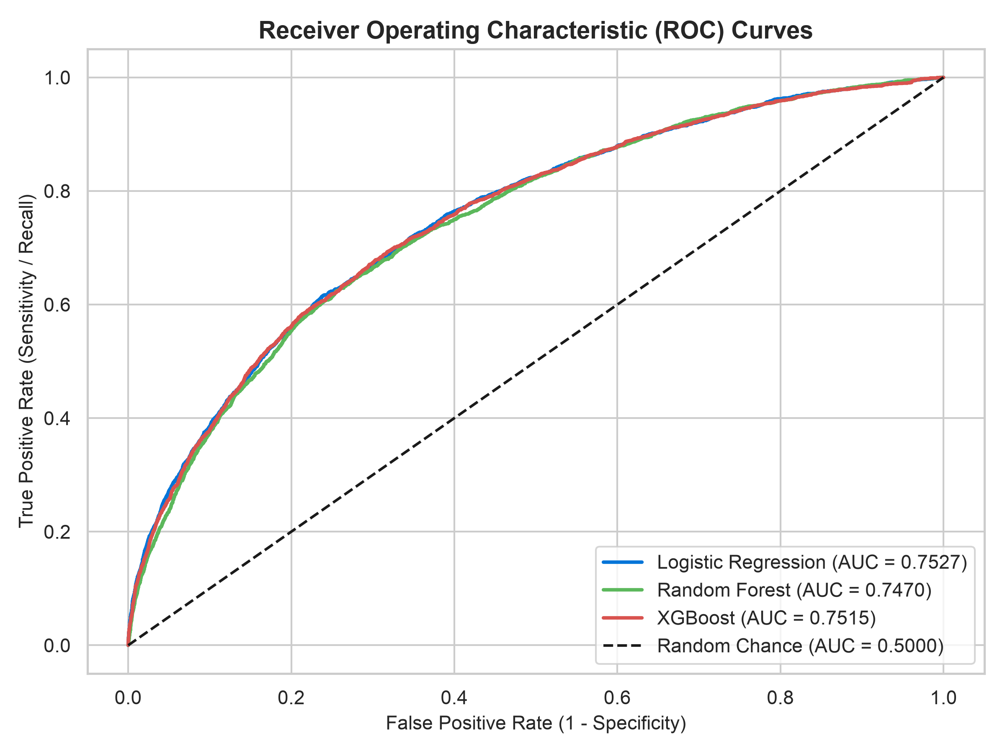
Figure: Receiver Operating Characteristic (ROC) Curves Across Models
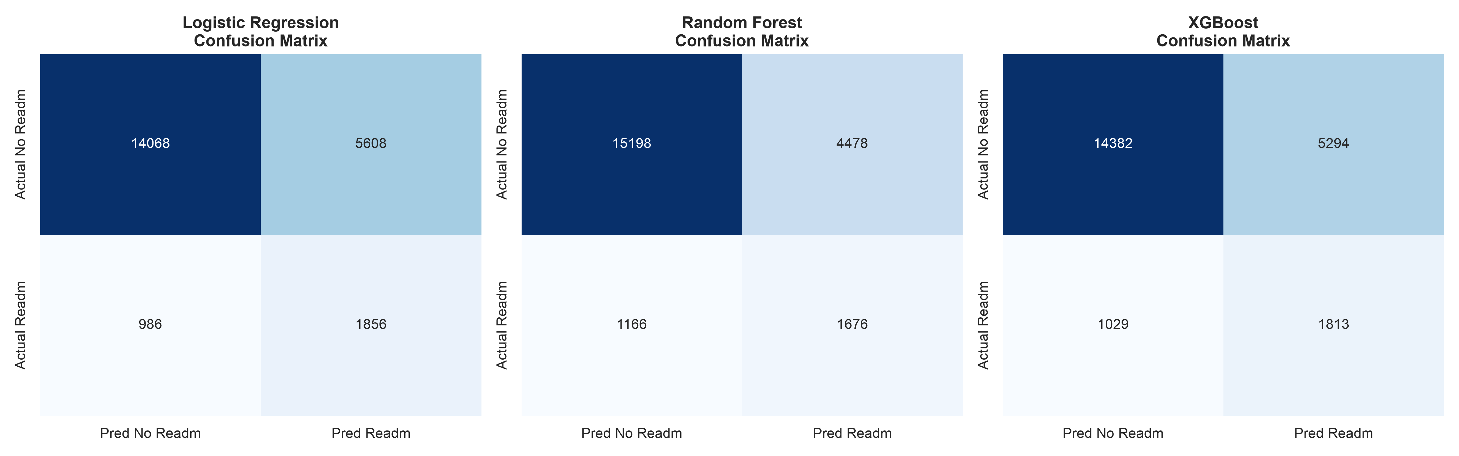
Figure: Confusion Matrices on 22,518 Unseen Holdout Encounters
16. Explainable AI (SHAP) Analysis
To ensure trust and clinical transparency, TreeExplainer SHAP (SHapley Additive exPlanations) analysis was conducted on the fitted XGBoost classifier across 1,000 representative validation encounters. SHAP attributes feature contributions to model log-odds predictions.
Predictor Feature | Mean |SHAP Value| | Model Association & Direction of Impact
los_days | 0.2870 | Extended hospital stay is strongly associated with elevated readmission risk
comorbidity_count | 0.2478 | Higher number of chronic pre-existing conditions increases predicted risk
charlson_index | 0.2170 | Higher Charlson comorbidity score contributes positively to readmission prediction
ward_type_ICU | 0.1522 | ICU accommodation during stay is associated with higher readmission probability
prev_admissions | 0.1354 | History of frequent prior admissions increases model risk score
insurance_type_Private | 0.1281 | Insurance classification modulates access and post-discharge encounter capture
admit_type_Emergency | 0.0953 | Acute emergency intake is associated with higher predicted readmission
bpl_card_True | 0.0886 | Below Poverty Line status contributes to higher readmission vulnerability
haemoglobin | 0.0865 | Lower haemoglobin levels (<12 g/dL) contribute to elevated readmission risk
age | 0.0695 | Advanced patient age contributes positively to predicted readmission risk
Methodological Note: High SHAP values indicate strong model attribution and statistical association with readmission. SHAP values do NOT represent clinical causality.
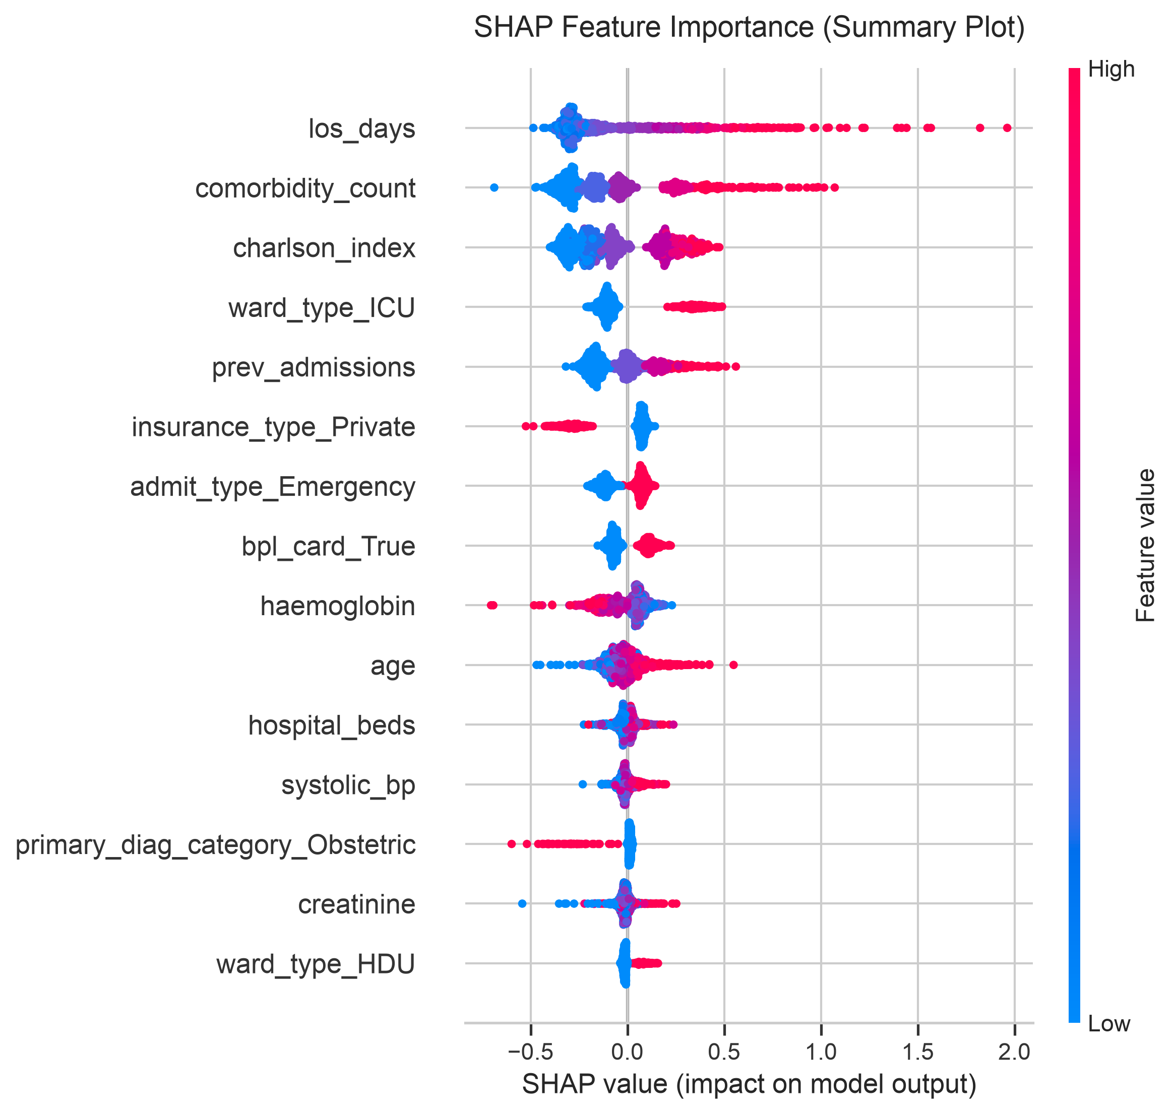
Figure: SHAP Feature Importance Summary Dot Plot
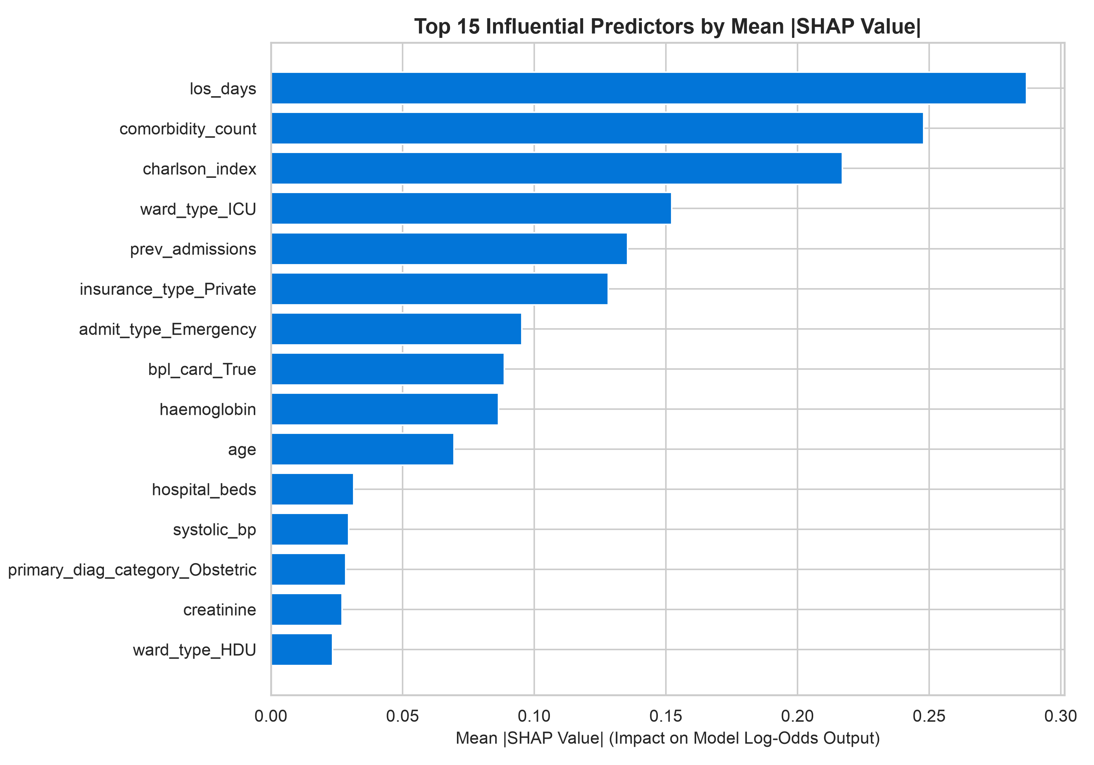
Figure: Top 15 Influential Predictors by Mean Absolute SHAP Value
17. Key Findings: Structured Analytical Framework
Major findings structured through the KPI -> TREND -> DRIVER -> RISK / OPPORTUNITY -> ACTION framework:
Finding 1: Post-Intensive Care Readmission Vulnerability
• KPI: 30-Day readmission rate of 12.62% in surviving cohort, rising to 23.76% among ICU-treated patients.
• Trend: Critical care survivors exhibit 1.25x the readmission rate of general ward patients.
• Driver: Acute multiorgan compromise, severe deconditioning, and complex post-discharge medication regimens.
• Risk/Opportunity: Unplanned readmissions from ICU crowd tertiary facilities and incur high treatment costs.
• Action: Implement mandatory ICU transitional step-down checklists and scheduled telephonic follow-up at 48 hours post-discharge.
Finding 2: The Left Against Medical Advice (LAMA) Readmission Spike
• KPI: 15,429 patients (12.86% of total admissions) were discharged LAMA, exhibiting an alarming readmission rate of 17.80% (2,747 readmissions).
• Trend: LAMA represents the single highest readmission rate across all discharge dispositions.
• Driver: Catastrophic out-of-pocket costs (mean OOP ₹48,173) and lack of financial counseling force patients to self-discharge prematurely.
• Risk/Opportunity: Premature discharge leaves active infections and acute conditions unresolved, leading to rapid emergency relapses.
• Action: Deploy dedicated hospital financial counselors and social workers to negotiate emergency subsidies before LAMA discharge paperwork is processed.
Finding 3: High Out-of-Pocket Expenditure Driving Care Discontinuation
• KPI: Average total cost is ₹95,779.53, with households bearing 50.30% (₹48,173.36) out-of-pocket.
• Trend: While government schemes cover 49.70% overall, uninsured patients (28.61% of registry) absorb nearly 100% OOP.
• Driver: Pharmacy and room charges represent over 55% of total billing.
• Risk/Opportunity: High OOP costs lead to medication non-adherence and subsequent disease relapse.
• Action: Establish bedside welfare enrollment for Ayushman Bharat (PM-JAY) and enforce generic medication formularies.
18. Risks & Strategic Opportunities
A synthesis of operational, clinical, financial, and AI risks alongside their corresponding strategic opportunities:
Strategic Domain | Identified Operational / Clinical Risk | Strategic Healthcare Opportunity
Clinical Quality | Rapid 7-day readmissions (0.84% overall, 1,006 encounters) indicating premature discharge or clinical instability. | Protocolized discharge readiness scoring combining vital sign stability and caregiver competency.
Bed Capacity & Flow | Long-stay patients (>10 days) occupying 21.4% of total bed-days, causing emergency boarding. | Establishment of sub-acute step-down care facilities and home-based community nursing.
Financial Solvency | Uninsured patient defaults and catastrophic OOP costs driving LAMA self-discharges. | Point-of-admission universal PM-JAY screening and emergency charity fund navigation.
Predictive AI Governance | Risk of false negatives missing deteriorating patients and false positives causing nurse alert fatigue. | Two-stage screening protocol combining automated EHR risk scoring with clinical nurse validation.
19. Recommended Actions & Phased Implementation Roadmap
Based on the empirical findings, a phased implementation roadmap is recommended:
Phase 1: Immediate Execution (Months 0 – 3)
1. Deploy Machine Learning Risk Stratification in EHR: Integrate the Logistic Regression / XGBoost probability scorer into hospital Electronic Health Record systems to calculate a patient-specific Readmission Risk Index upon inpatient discharge planning.
2. Establish LAMA Intervention Protocol: Mandate clinical social worker and financial counselor consultation for every patient initiating a LAMA request to address financial and logistical barriers prior to discharge.
Phase 2: Medium-Term Operational Scaling (Months 3 – 9)
3. Standardize 48-Hour Telephonic Follow-Up: Assign hospital transitional care nurses to execute protocolized telephone check-ins at 48 hours and 7 days post-discharge for all patients in the top risk quintile (targeting medication adherence and warning signs).
4. Pharmacy Formulary Optimization: Enforce hospital-wide dispensing of generic essential medications to reduce out-of-pocket pharmacy burden.
Phase 3: Long-Term Systems Transformation (Months 9 – 18)
5. Regional Step-Down & Primary Care Integration: Link tertiary hospitals with district health centers and primary care clinics to ensure scheduled 14-day post-discharge outpatient follow-up consultations.
6. Universal Health Coverage Expansion: Accelerate PM-JAY and state insurance enrollment at hospital admission counters to eliminate the 28.6% uninsured rate.
20. Limitations, Future Scope & Conclusion
Study Limitations:
1. Observational Design: Findings reflect observational statistical associations. Clinical causation cannot be inferred without prospective randomized clinical trials.
2. Outpatient Adherence Gap: Post-discharge outpatient medication refill adherence and family caregiving dynamics were unobserved in the administrative dataset.
3. Geographic Specificity: While encompassing 33 hospitals across 15 states in India, external validation across international healthcare systems is warranted.
Future Scope:
1. Clinical Natural Language Processing: Incorporating physician discharge notes and radiology summaries using clinical large language models.
2. Prospective Clinical Trials: Conducting randomized trials evaluating the efficacy of ML-triggered transitional care phone interventions.
3. Real-Time FHIR API Integration: Implementing standardized HL7/FHIR microservices for point-of-care clinical decision support.
Conclusion:
This project successfully delivers an end-to-end analytical and machine learning investigation of hospital performance, patient flow, and 30-day readmissions across 120,000 inpatient admissions. By rigorously preserving the analytical grain of one admission per row, preventing target leakage, and utilizing SHAP explainability, the study provides a transparent, scientifically sound, and clinically actionable framework for improving patient outcomes and hospital operational resilience.

